Near clipping plane

Far clipping plane

+Y axis

-Z axis

camera

model

Side edge of viewing window

projection

fovy

angle in

degrees

Near clipping plane

Far clipping plane

+Y axis

-Z axis

camera

Clipping a triangle to a rectangular region can possibly produce

a point, a line, a triangle, a 4 sided polygon, a 5 sided polygon, or

a 6 sided polygon, which must be broken into triangles.

Near clipping plane

Far clipping plane

+Y axis

-Z axis

camera

View Window

vertex (x,y,z)

y

y’

z

near

perspective transformation

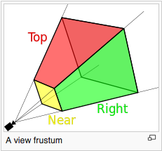

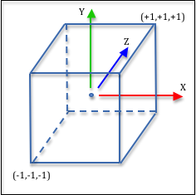

lower precision

higher precision

z values (original data)

z' values (clipping volume)

gl.viewport(x, y, width, height)

+Y

view_width

view_height

xOffset

+X

yOffset